**Validation Screenshots**

**Sameer Ali Hemani 37909**

**Hosted Website Url**

[samwebs.000webhostapp.com](https://samwebs.000webhostapp.com/" \t "_blank)

**HTML File 1**

**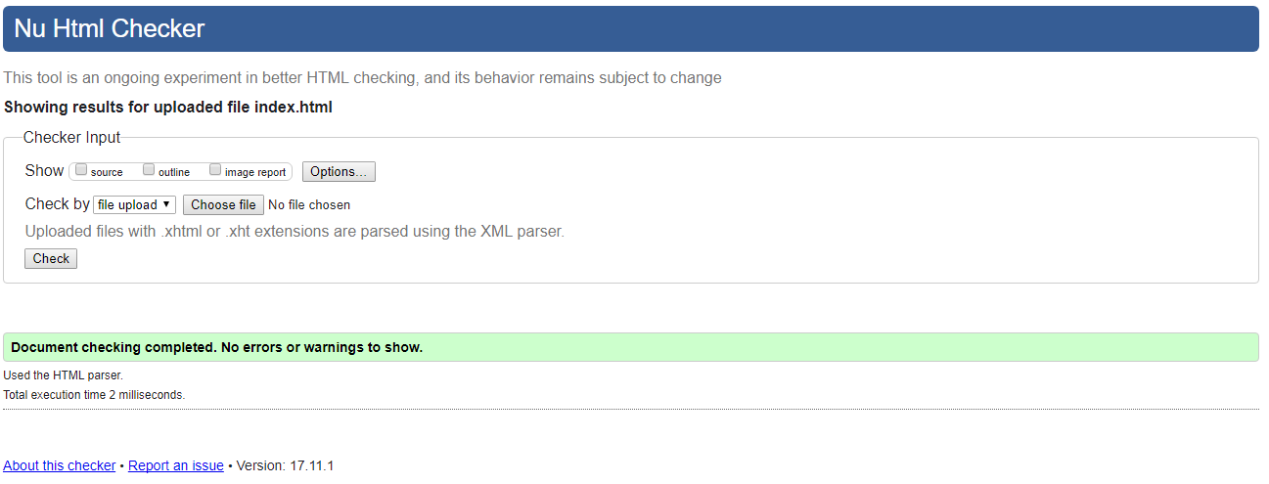**

**My HTML File 2**

**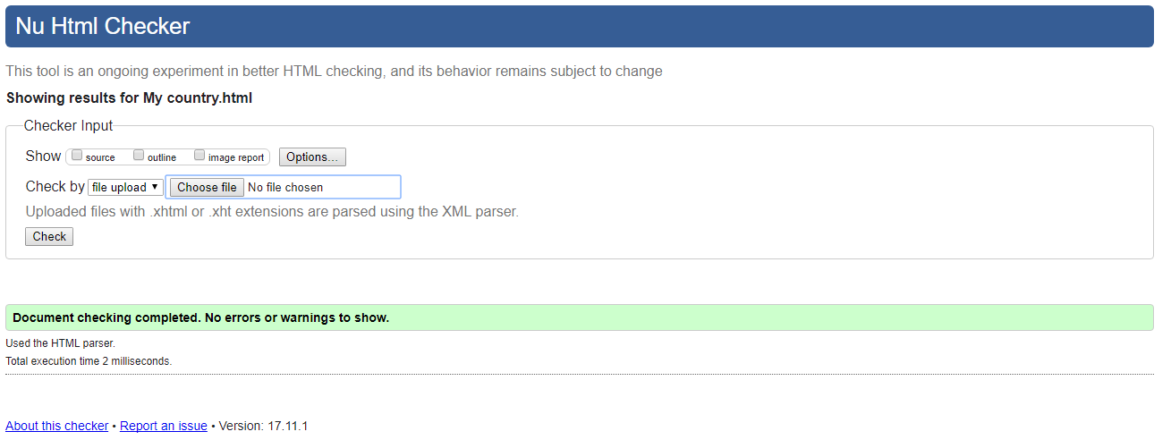**

**My CSS File**

**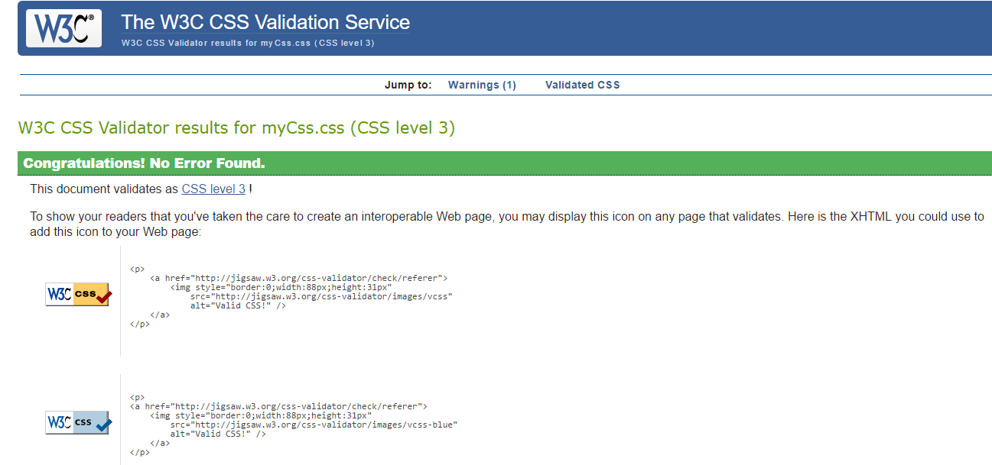**

**My Javascript File**

**